I)Project chater-

II) CRISP ML(Q)- cross industry standard process machine learning Quality Assurance is the project management methodology

Descriptive Analytics in solving the problem trying to find out what has happened.
Diagnostic Analysis- We dragonize why did the problem happen(Batch scales and comparison models)
Predicting- Forecasting and understanding the real time MVDA process monitoring
Prescriptive- how can we make it happen or what should be done i.e Decision making(possible outcomes of a simulation, control points, automation etc)

1)Understanding the business scenario
2)Data cleaning/descriptive analysis/Exploratory analysis
3)Data Mining and Machine learning models

III) Data Architecture
8 layers
1)Ingestion Layer
These first 6 layers ensure data is moving from the raw source to its value of its customers.
2)Data Collection layer
3)Data processing layer
4)Storage layer
5)Query layer
6)Visualization layer
7)Security layer
8)Monitoring layer

IV) Data understanding and collection

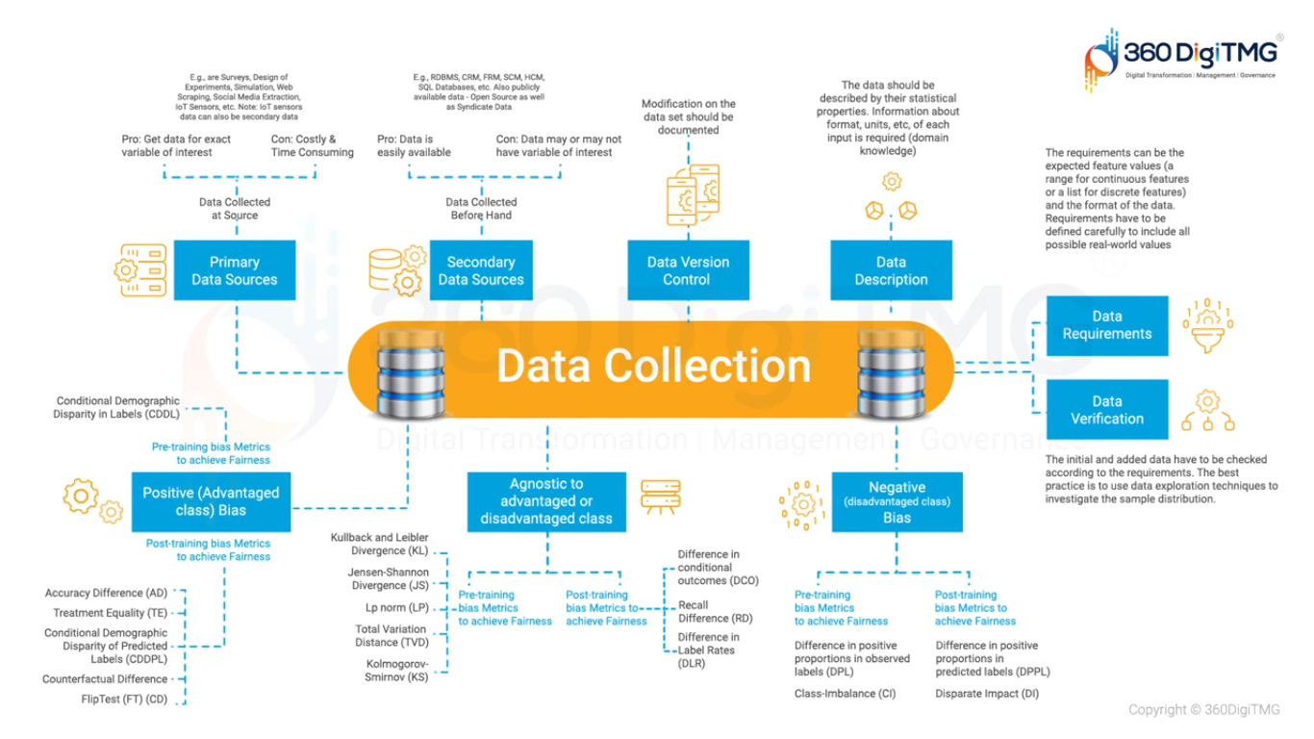

V) Autoviz is a Python library for automatic visualization that can generate various types of charts based on a given dataset. Its design goal is to make the data exploration and analysis process more efficient and convenient, eliminating the need for manually writing extensive visualization code.Autoviz gives the multiple plots in a single line of code.

We try to establish a connection to a company’s SQL data base using the python package called sqlalchemy and we create an Engine using the authentication i.e user root and password:23MBMA14.

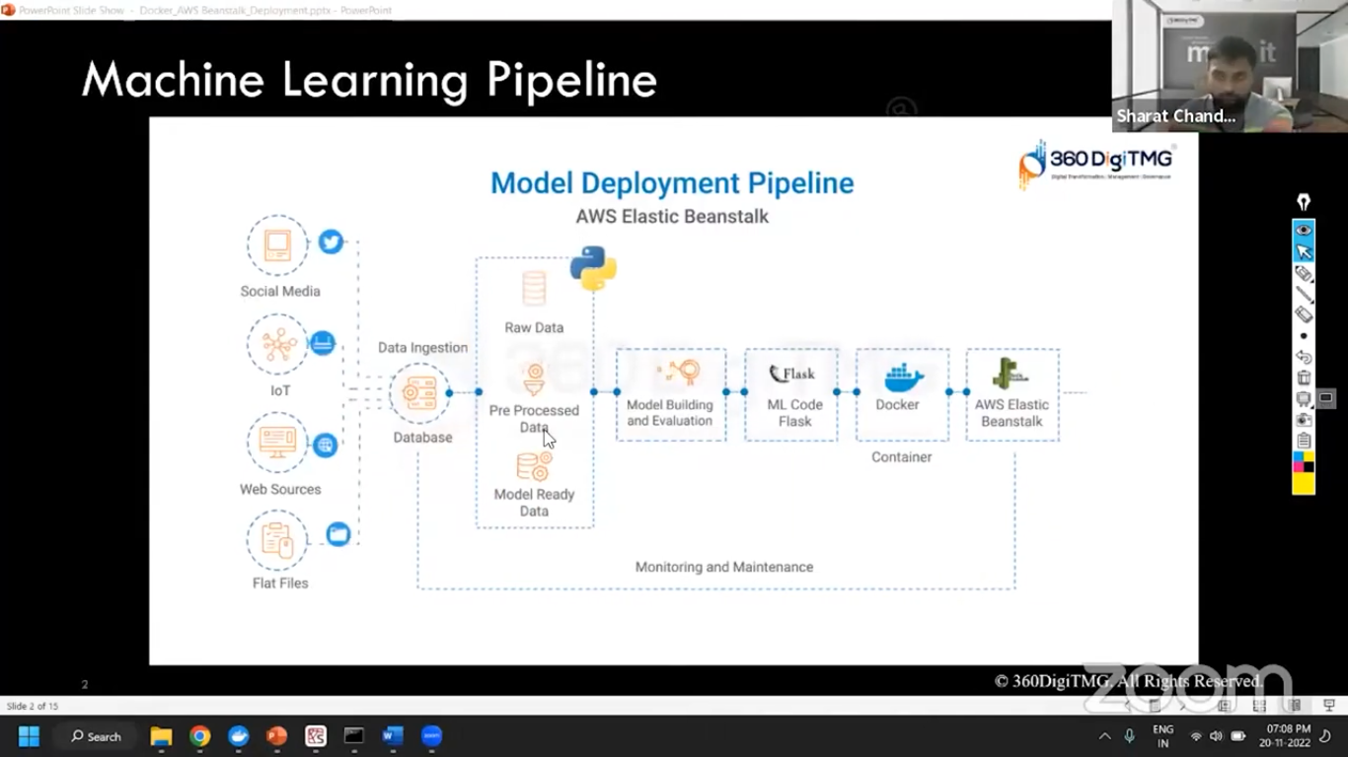
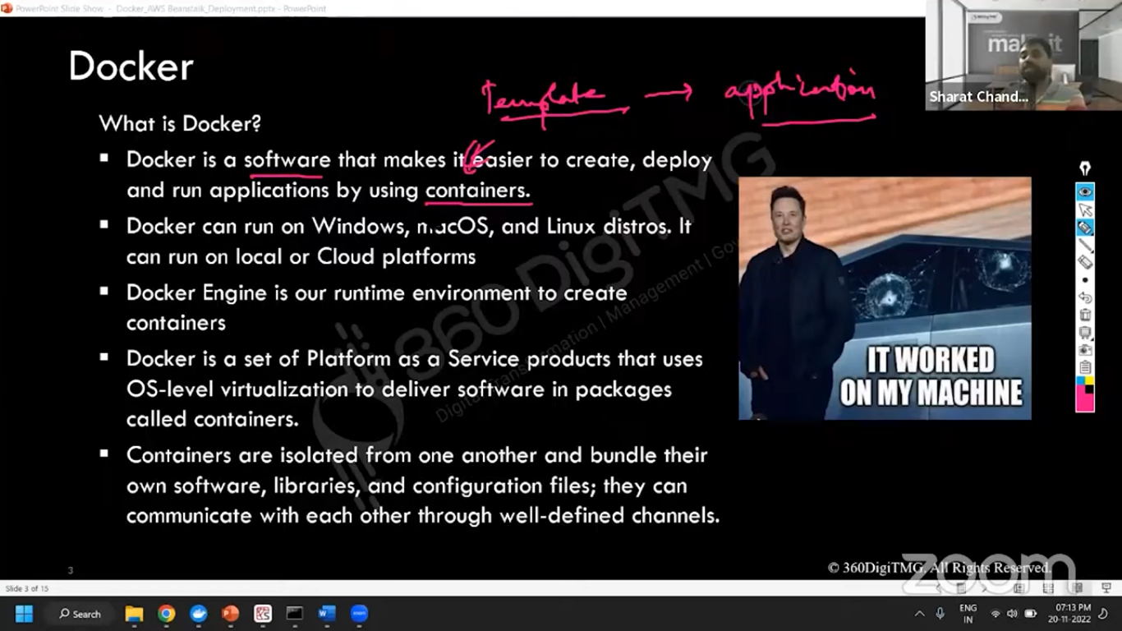
joblib

